Anterior Approach Total Hip Replacement
A minimally invasive alternative to traditional hip replacements

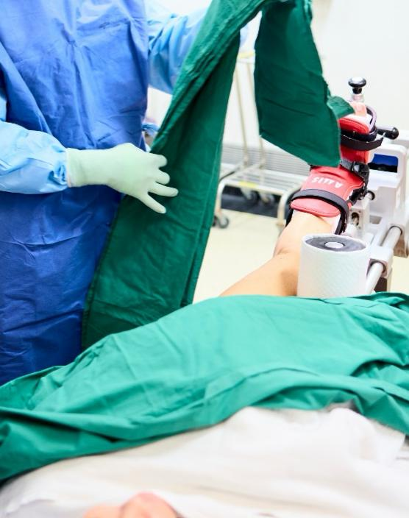
The anterior approach is one of several surgical techniques used to access the hip joint during total hip replacement surgery. In this technique, the hip joint is approached from the front of the body (anterior aspect) rather than from the side or back.

The anterior approach is one of three commonly used surgical approaches for hip replacement, alongside the posterior approach and the lateral (or anterolateral) approach. Each method provides a different pathway to the hip joint, and the most appropriate technique varies depending on the patient’s anatomy, the condition affecting the hip joint, and the surgeon’s assessment.

Dr Paul Harvie performs hip replacement surgery using contemporary surgical techniques and will recommend the most appropriate surgical approach following careful clinical evaluation.

How the Anterior Approach Accesses the Hip Joint
During an anterior approach hip replacement, the hip joint is accessed from the front of the hip by working between natural muscle planes. This approach allows Dr Harvie to reach the joint without detaching major muscles from bone. Once the joint is accessed, the damaged surfaces of the hip joint are carefully removed and replaced with prosthetic components designed to recreate the natural ball-and-socket movement of the hip. Because Dr Harvie works between muscles rather than detaching them, the anterior approach is often described as a muscle-sparing technique and in selected patients, this approach may support early movement following surgery.

How the Anterior Approach Differs from Other Hip Replacement Approaches
- Posterior Hip Replacement: In the posterior approach, the hip joint is accessed from the back of the hip. This has historically been the most widely used approach worldwide and provides excellent visualisation of the hip joint for implant placement.
- Lateral (Anterolateral) Hip Replacement: The lateral approach accesses the hip from the side. It may involve partial detachment of the hip abductor muscles to reach the joint.
- Anterior Hip Replacement: The anterior approach accesses the joint from the front of the hip, working between muscles rather than detaching them. For appropriately selected patients, this may assist with early movement following surgery.

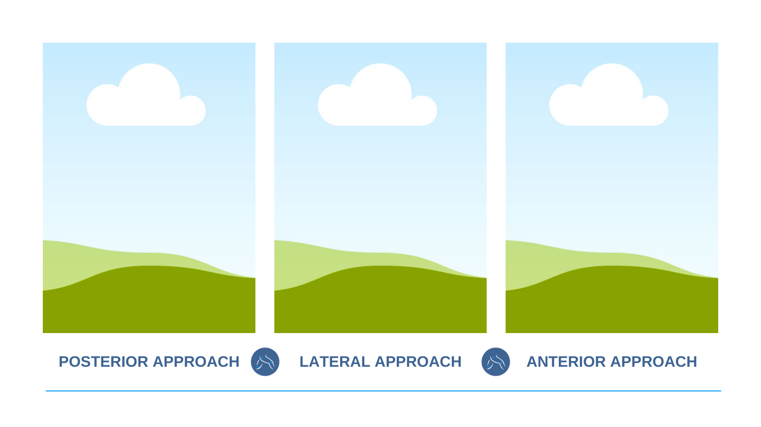

Each approach has advantages and considerations, and the most suitable technique is determined individually.

Anterior Approach Surgical Planning and Technique
Careful planning is an important part of anterior hip replacement surgery. Prior to surgery, Dr Harvie performs a thorough clinical assessment and reviews detailed imaging to understand your hip anatomy and the condition affecting your joint.

This evaluation typically includes reviewing:
• Your symptoms and how they are affecting your mobility and daily activities
• The shape and alignment of your hip joint
• X-rays or other imaging studies
• Bone quality and the extent of joint damage
• Any previous treatments or surgery involving the hip

Where appropriate, patient-specific surgical planning may also be used. This involves analysing imaging of your hip joint to help guide implant positioning and component orientation during surgery. By carefully assessing your individual anatomy and joint structure, Dr Harvie can plan the surgical technique and implant positioning that may best support hip stability, movement, and long-term joint function.

Anterior Approach Incision Placement
During anterior hip replacement surgery, the skin incision is typically made at the front of the hip to allow access to the joint. In some patients, this may be a vertical incision, while in others it may be placed along the natural crease of the groin, often referred to as a bikini-line incision.

The choice of incision depends on several factors, including your individual anatomy, body shape, and the overall surgical plan. Both incision types allow access to the hip joint using the anterior approach.

Is the Anterior Approach Suitable for Everyone?
Not every patient is suited to the anterior approach. Factors that influence surgical planning include:
• Body shape and soft tissue anatomy
• Severity of hip arthritis or joint damage
• Bone structure and alignment
• Previous hip surgery
• Overall health and mobility

For this reason, the decision regarding surgical approach is made on a case-by-case basis and during your consultation Dr Harvie
will assess your symptoms, review imaging studies, and discuss both surgical and non-surgical treatment options, including whether anterior approach hip replacement may be suitable for your condition.

LEARN MORE ABOUT TOTAL HIP REPLACEMENT SURGERY

